Exploratory Data Analysis & Descriptor/Fingerprint Calculation
- Report statistic for exploratory analysis:
📊 Statistical Summary of pIC50
The dataset contains 297 compounds with valid pIC50 values.
The mean pIC50 value is 6.68, with a minimum of 4.75 and a maximum of 8.22.
The standard deviation is 0.64, indicating relatively low variability among the compounds.
Overall, the results suggest that most compounds exhibit moderate biological activity, with the majority of values clustered around the mean. The relatively small standard deviation indicates that the dataset is fairly consistent in terms of bioactivity distribution.
- histogram_pic50

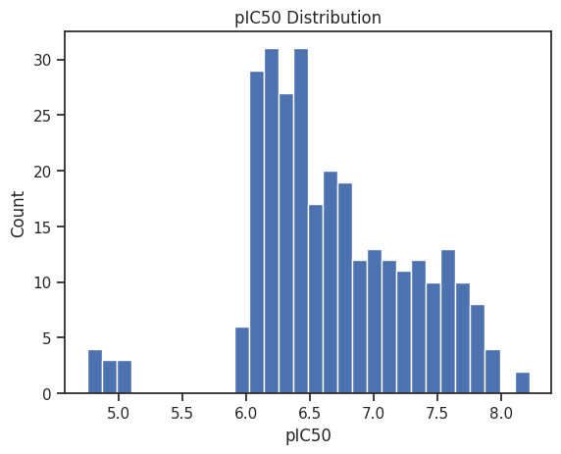
The histogram of pIC50 values (ranging from 5.0 to 8.0 with 0.5 intervals) shows that the majority of compounds are concentrated around 6.2, where the count reaches 28.
The distribution rises gradually from 5.0–6.0 with moderate counts (around 5 compounds per bin), peaks at 6.2 and 6.5, and then decreases steadily towards higher pIC50 values, indicating that most compounds have moderate to high bioactivity

- Barplot_bioactivity_class
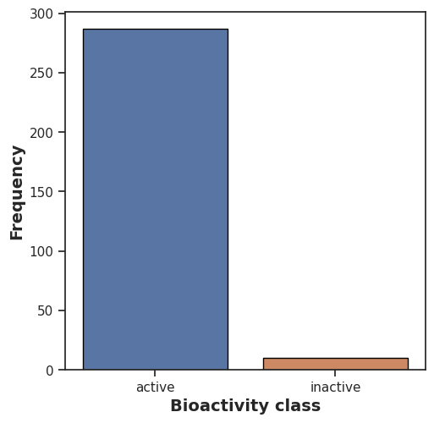
The bar plot shows the distribution of compounds across bioactivity classes. The Active compounds dominate the dataset, with a count of approximately 290, while the Inactive compounds are very few, barely above 0. This indicates that the dataset is highly imbalanced, with almost all compounds being biologically activity.

- Lipinski and 2D descriptor statistics:

We calculated the Lipinski descriptors using RDKit. A total of 4 descriptors were computed for 297 compounds. The descriptors include:
- Molecular Weight (MW)
- LogP
- Number of Hydrogen Bond Donors (NumHDonors)
- Number of Hydrogen Bond Acceptors (NumHAcceptors)
Afterwards, we computed the statistical summary for these two-dimensional descriptors, including mean, minimum, maximum, and standard deviation, to provide an overview of the molecular properties across the dataset.

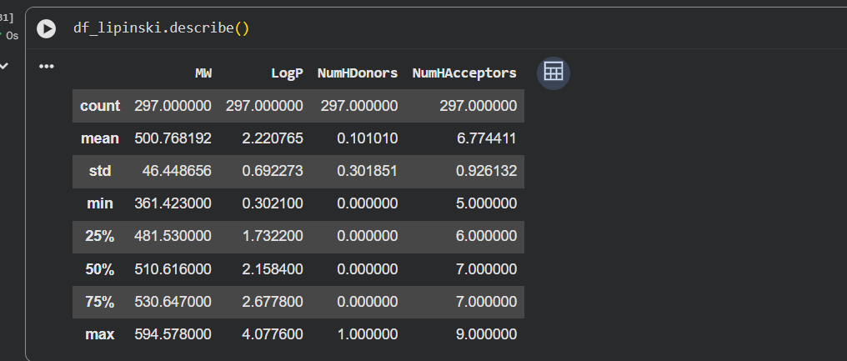

The statistical summary of the four Lipinski descriptors for the 297 compounds is as follows. The molecular weight (MW) ranges from 361.423 to 594.578, with an average of 500.768 and a standard deviation of 46.449, indicating most compounds are of medium size
LogP values range from 0.302 to 4.078 (mean = 2.221, std = 0.692), showing a good balance between water and lipid solubility. The number of hydrogen bond donors (NumHDonors) is mostly 0, with few compounds having 1 (mean = 0.101, std = 0.302), while the number of hydrogen bond acceptors (NumHAcceptors) ranges from 5 to 9 (mean = 6.774, std = 0.926), indicating moderate hydrogen bonding potential. These statistics provide an overview of key two-dimensional molecular properties across the dataset.

Scatter of Molecular Weight vs Solubility (LogP)

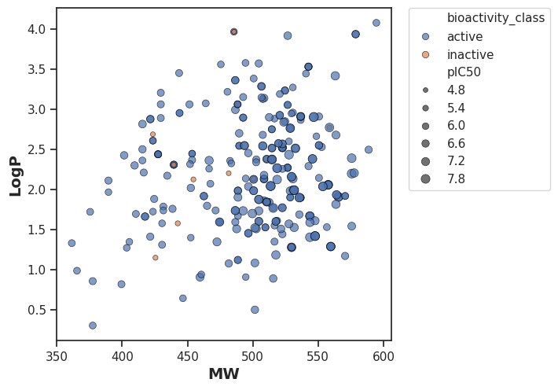
Most compounds are located in the MW range of 450–550, indicating medium-sized molecules. Most blue points fall between LogP 1.5–3, suggesting moderate solubility
The result reflects a stable and reasonable set of compounds for biochemical experiments, with some useful diversity for analysis.
This is an initial visual inspection. We needed to perform a Mann-Whitney test to determine whether the differences between the two groups (active vs inactive) are statistically significant. The results were as follows:

The Mann-Whitney test results for the descriptors are as follows:
MW: U = 2100.0, p = 0.0128 → significantly different between active and inactive compounds.
NumHAcceptors: U = 1902.5, p = 0.0627 → no significant difference.
LogP: U = 1209.0, p = 0.3983 → no significant difference.
pIC50: U = 2870.0, p = 7.73e-08 → significantly different.
NumHDonors: U = 1436.5, p = 0.9943 → no significant difference.
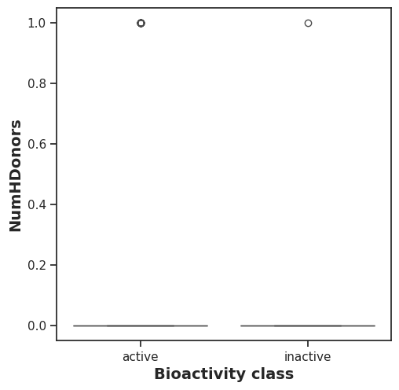
In summary, MW and pIC50 show statistically significant differences between active and inactive compounds, while the other descriptors do not.
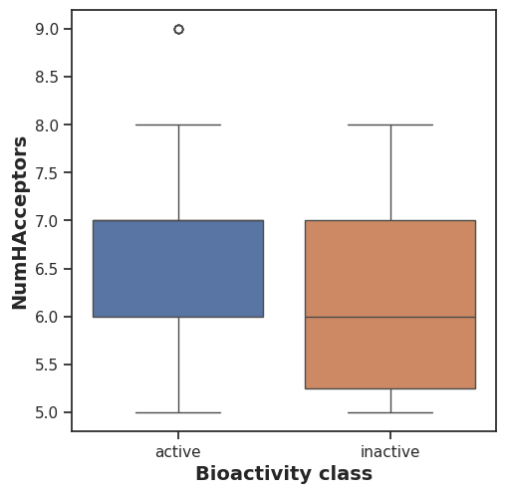
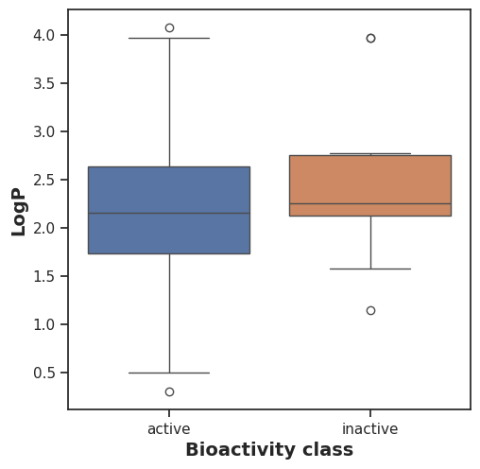
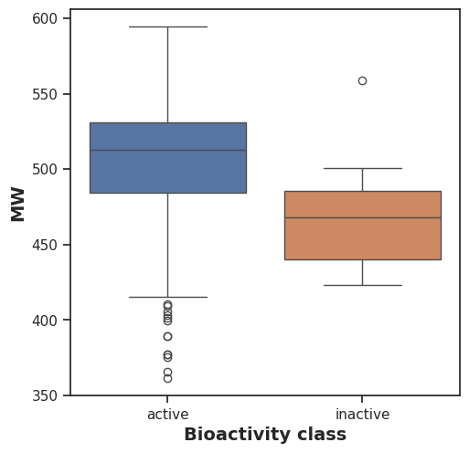

- Pubchem Fingerprints
Fingerprints were generated using PaDEL-Descriptor with PubChem fingerprints, chosen because they provide a comprehensive and standardized representation of molecular substructures. PaDEL-Descriptor can calculate 12 different types of fingerprints, and PubChem fingerprints are particularly suitable for large and diverse datasets like ours, making them ideal for similarity analysis, QSAR modeling, and machine learning applications.

